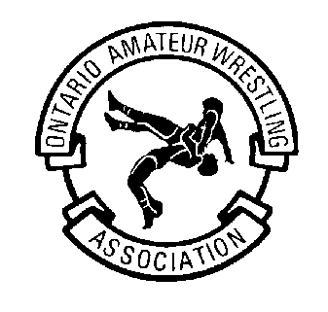
London-Western Wrestling Club

Western Wrestling

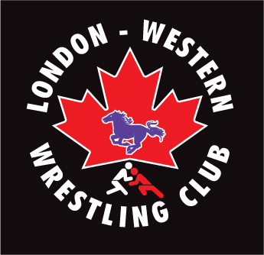
Ontario Amateur Wrestling Association

Membership Form 2019/20

Last Name___________________________________________ First Name_____________________________________
^{please print neatly}

Birth date: ________ mm/_________dd/______________yyyy Gender: _____Male: _____ Female:

Address__________________________________________________________________________________________

City______________________________ Prov._________ Postal Code_____________________________

Home Phone ( ) _______________________________ Cell ( )_________________________________________
E-Mail Address____________________________________________ Health Card _________________________________

School: _________________________________ Grade: _____ School coach: ___________________________________

How did you hear about the London-Western Wrestling Club? ___________________________________________________

Father’s Name: ___________________________________ Occupation: ________________________________(optional)

Mother’s name: ___________________________________ Occupation: ________________________________(optional)

Previous experience (years wrestling): __________ Others Sports involvement/background: ________________ ________________________________________________________________________________________________________________________________________________________________________________________________________

Divisions: _____ Athlete _____ Coach ____ Official ____ Supporter ____ Wrestling Alumni (Western or Club)

Emergency contact: In case of emergency --- contact the following person(s):

Name (relationship): _______________________________________________ phone: ( ) _______________________

Name (relationship): _______________________________________________ phone: ( ) _______________________

May we have permission to list results, take photographs, or show video which may be used on our website, in print, electronic media and/or newspapers? ___ Yes

Is there any (medical) condition the Coaching Staff should be aware of while participating? ___ Yes ___ No (please list and explain in person if necessary) List any Allergies/Medication. Note: It is advised that all participants get a medical check-up prior to participation.
____________________________________________________________________________________________________
____________________________________________________________________________________________________
____________________________________________________________________________________________________

Ontario Amateur Wrestling Association (OAWA) & London-Western Wrestling Club
Membership Agreement Waiver

NOTE: If you are a new member you must send proof of age with your payment and this completed form. Without these, your registration will not be processed. Acceptable Proof of Age: Copy of (birth certificate, driver’s license or a letter from your school verifying birthdate and signed by the principal, on school letterhead.)
Make all cheques payable “London-Western Wrestling Club”
Return Forms to: Sue Perkins (Membership Coordinator)

ALL SPORT, INCLUDING WRESTLING, HAS ITS RISKS

The risk of injury from the activities involved in this program is significant, including the potential for permanent paralysis and death, and while particular rules, equipment, and personal discipline may reduce this risk, the risk of serious injury does exist. I participate in the sport of Wrestling because it is physically and mentally challenging. I know that there are physical risks and hazards inherent in Wrestling, as there are in most sports. These include but are not limited to:
- Muscular injuries resulting from vigorous physical exertion
- Injuries to the eyes, teeth, face and other parts and bruises and scrapes resulting from falling to the Wrestling mat or colliding with opponents.
- Serious injuries, including permanent or temporary, total or partial disability, disfigurement, paralysis, and any other losses or damages to person or property or death.

I KNOWINGLY AND FREELY ASSUME ALL SUCH RISKS, both known and unknown, and assume full responsibility for my/my child's participation; and, additional risks associated with my travel to and from events, and associated with non-competitive activities related to events and other activities.

I AGREE TO BE RESPONSIBLE FOR MYSELF. I am participating voluntarily in Wrestling. I agree that there are risks in Wrestling, as described above. By participating voluntarily in Wrestling, I am exposed to these risks and hazards. I agree to accept them and be responsible for any injury or other loss which I might receive while participating in Wrestling.

If something happens to me, I release the organizers of responsibility for any claims, demands, actions and costs which might arise out of my participation. In this Agreement I understand "organizers" to mean: the Ontario Amateur Wrestling Association, the Wrestling Club as listed above/herein, the Canadian Amateur Wrestling Association, and each of their respective directors, officers, employees, coaches, officials, volunteers and members.

I also verify that I am aware of the OAWA Harassment Policy and Code of Conduct and Privacy of Information Policy, and agree to abide by/be bound by these policies. I Consent to the collection, use, and disclosure of this information as required to facilitate my participation in OAWA and related programs. I further consent to the disclosure of my personal information to the Canadian Amateur Wrestling Association as required for the participation in programs of that organization. Coaches consent to the release of their home phone numbers and other similar information for use in the promotion of the club they are involved in at the discretion of the OAWA. I hereby grant the Ontario Amateur Wrestling Association the irrevocable right to use and disclose, at their sole discretion, any information about me and my participation in Association programs for publicity, advertising, or other promotion of the Association or its programs or for the purpose of acknowledging or publicizing my achievements at events. I understand that this may include written, pictorial, or video materials.

Release of Information acknowledgement: I allow London-Western to release results, such as tournament results, photographs, and other information that are related to club activities on its website.
Please check √ below to acknowledge your agreement:
- Applicant: I HAVE READ, UNDERSTAND, AND AGREE TO THE ABOVE.
Or, I am the Parent or Legal Guardian if the applicant is under 18 years of age and I have read, understand, and agree to the above.

This is a legal agreement. It is binding upon me as well as upon my heirs, executors and representatives. I have read and understood all its terms and by signing it voluntarily I am agreeing to abide by these terms.

Applicant’s Name: ______________________________________* Applicant’s Signature: ____________________________________
* Signature of Parent/Guardian (if applicant is under 18)
Date: ___________________________

Witness’ Name: ____________________________________ Witness’ Signature: ________________________________________
Date: ___________________________

Please attach a photo copy of proof of age (e.g., birth certificate, health card)

